NAME : AMPWERA JAVAN
Reg.No: 2025/BCS/079/PS
GROUP: ONE
PROJECT NAME: ONLINE SHOPPING
AREA OF INTEREST: FULFILLMENT AND LOGISTICS

THE REPORT THE FULFILLMENT AND LOGISTICS
- Order fulfillment and logistics involve all processes from when a customer places an order to when the product is delivered. This includes order processing,inventory, shipping, returns if the product has issues and delivery tracking.
- Fulfillment and logistics in online shopping refers to everything that happens after a customer places an order until the product is successfully delivered to them.

1. Fulfillment
Fulfillment is the process of getting the order ready for the customer.
It includes:
- Order processing – confirming the order in the system
- Picking – selecting the items from the warehouse
- Labeling – adding shipping details
- Dispatching – handing the package over for delivery
Example: When you order a phone online, fulfillment is the process of finding it in the warehouse, packing it, and preparing it for shipment.

2. Logistics
Logistics is about moving the product from the seller to the customer.
It includes:
- Transportation – delivery by trucks, bikes, planes, etc.
- Shipping management – choosing delivery routes and methods
- Tracking – letting customers know where their order is
- Delivery – final drop-off to the customer
- Returns handling – managing returned items
Example: The journey of your package from the warehouse to your home is logistics.

1. Processes Involved

a. Order Processing
- Customer places an order
- System verifies product availability
- System checks payment
- Order is confirmed and recorded
This is the order structure in my database
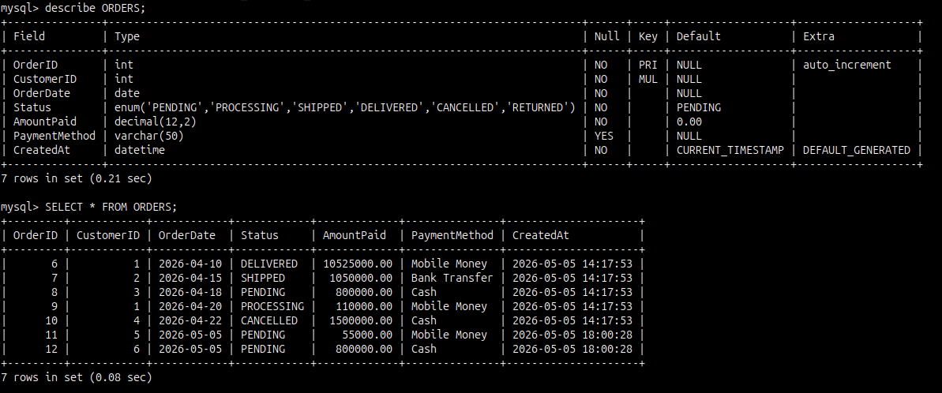

b. Inventory Handling
- Stock is reduced after order confirmation
- If stock is low → alert admin
This is the structure of inventory in my database
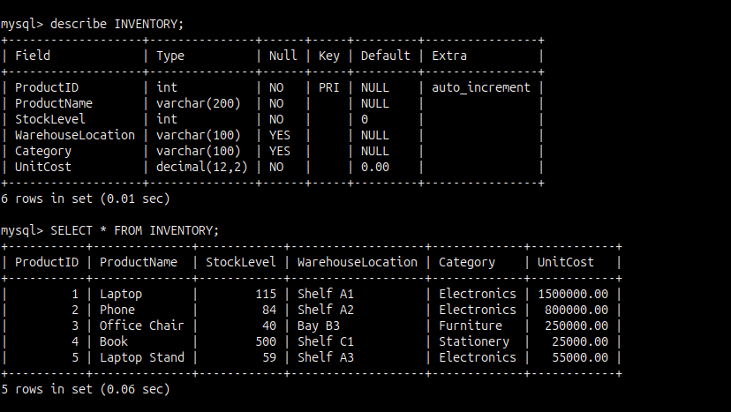

d. Shipping
- Order is dispatched
- Shipping details recorded (date, method)
This is the structure of shipment in my database
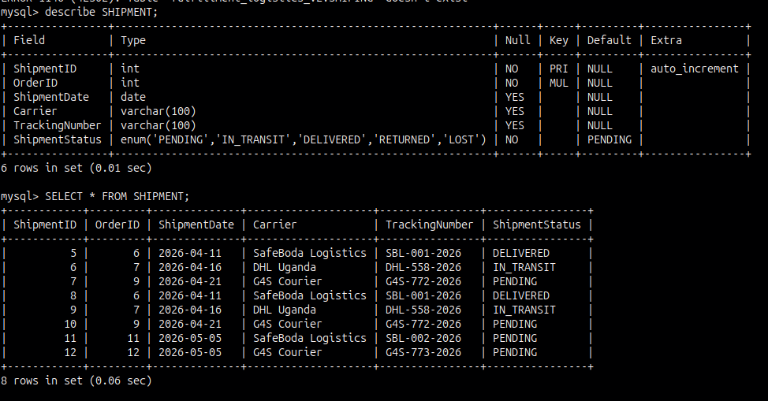

e. Delivery
- Order delivered to customer
- Delivery status updated
This is the structure of delivery in my database
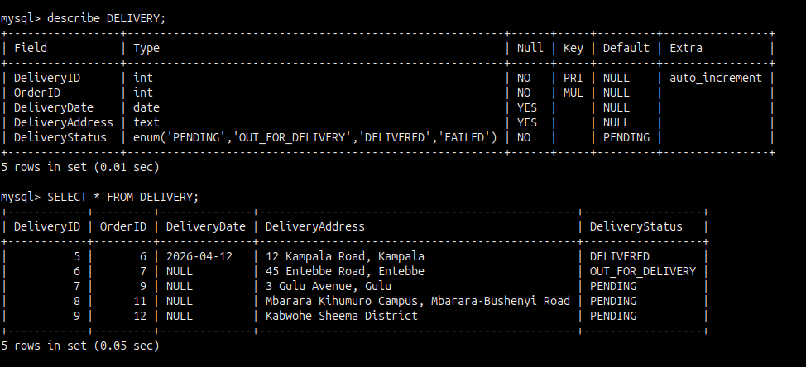

2. Database Design for Logistics

a. Relevant Entities

Order (existing)
- OrderID
- Customer,s number
- CustomerID
- OrderDate
- items ordered
- Amount paid
- Status (Pending, Shipped, Delivered)

Delivery
- DeliveryID
- OrderID
- DeliveryStatus (Pending, In Transit, Delivered)
- DeliveryDate
- DeliveryAddress

Shipment
- ShipmentID
- OrderID
- ShipmentDate
- Carrier
- TrackingNumber

b. Relationships
- One Order → One Shipment
- One product - many orders
- One order - multiple returns
- One Order → One Delivery
- One Customer → Many Orders

Why it matters in online shopping
- Good fulfillment and logistics:
- Ensure fast delivery
- Reduce errors (wrong items, delays)
- Improve customer satisfaction
- Help businesses save costs and scale

Benefits of using this database

Reduced Operational Costs
- Optimized delivery routes reduce fuel and transport costs
- Efficient warehouse management lowers storage expenses
- Example: Less money spent per order delivered

Faster Order Processing
- Automated database systems speed up:
- Order confirmation
- Inventory updates
These lead to shorter delivery times

Increased Sales and Revenue
- Faster and reliable delivery encourages more purchases
- Customers are more likely to order again

Better Inventory Management
- Real-time tracking of stock levels prevents overstocking

Improved Delivery Accuracy
- Fewer wrong deliveries due to organized data
- Reduced returns and replacement costs

Improved Customer Satisfaction
- Faster, reliable deliveries
- Easy tracking and communication
- These lead to happier customers

Transparency and Accountability
- Clear tracking of orders and deliveries make it easier to identify and fix problems

Risks

High Operational Costs
Transportation, warehousing, and labor can be expensive
Fuel price increases raise delivery costs

Delivery Delays
Poor route planning or system errors, Traffic, weather, or infrastructure issues leads to late deliveries and extra costs

Inventory Errors
Incorrect database records can cause issues like Overselling (selling items not in stock)
Overstocking

System Failures
Database crashes or downtime can stop order processing leading to delay fulfillment

This is the ER DIAGRAM FOR MY DATABASE
